Hunting with ELK (Lab 2)

LAB 16.2

Scenario
The IT Security manager provided you with simulated malicious activity and has asked you to create hunting detection techniques for all of it.
Full credit for the dataset goes to Sean Donnelly and Peter Hay. This lab provides answers to some of the workshop tasks that contained no solutions.

Goals
The learning objective of this lab is the rule generation ability and becoming more familiar with ELK.

What you will learn
You will learn how to utilize available logs to detect suspicious activity on a windows host.

Recommended tools
- ELK
- Access the Kibana at Web (http://demo.ine.local:5601)

Tasks

Task 1. Hunt for malicious use of rundll32
Attackers are known for leveraging native Windows' functionality/binaries to evade detection while executing malicious code.
Such an example is pcwutl.dll, that can be used to launch an executable by calling the LaunchApplication function. Details can be found in the resource below.
https://lolbas-project.github.io/lolbas/Libraries/Pcwutl/
Create a detection rule so that the blue team can proactively hunt for the usage of this functionality.

Task 2. Hunt for UAC Bypass leveraging cliconfg.exe
For this task you are tasked with creating an ELK search that can detect UAC bypasses leveraging cliconfg.exe.
Hint: Focus on Sysmon event ID 7 and search for the below Target and Component inside the process name and file path fields.
Author: Win32/Carberp derivative
- Type: Dll Hijack
- Method: WUSA
- Target(s): \system32\cliconfg.exe
- Component(s): ntwdblib.dll
- Implementation: ucmWusaMethod
- Works from: Windows 7 (7600)
- Fixed in: Windows 10 TH1 (10147)
  - How: WUSA /extract option removed

Task 3. Hunt for RDP settings tampering
Create detection rule that identifies suspicious changes to RDP settings.
Hint: Assume that RDP is not used by default. Any firewall change involves the netsh.exe binary.

Task 4. Hunt for DCSync
Research the DCSync technique and create a detection rule.
Hint: It is about time we introduce a great community project called Sigma (https://github.com/Neo23x0/sigma). According to its description, Sigma is a generic and open signature format that allows you to describe relevant log events in a straightforward manner. The rule format is very flexible, easy to write and applicable to any type of log file. Sigma converter can then be used to obtain Elastic search queries, Splunk search queries, etc.
Hint: Even without using Sigma's converter, we can create an ELK search query for DCSync by browsing the respective Sigma rule and doing the "translation" ourselves. See below the Sigma rule for DCSync.
https://github.com/Neo23x0/sigma/blob/master/rules/windows/builtin/win_dcsync.yml

Task 5. Hunt for Remote WMI Usage
Research and create an ELK detection search for Remote WMI Usage technique. A reference for WMI attacks is available here.
Hint: Focus on event ID 4648 -- logon with explicit credentials.
The below resource contains what you need to search for inside the event ID above.
https://jpcertcc.github.io/ToolAnalysisResultSheet/details/RemoteLogin-Mimikatz.htm

Task 6. Hunt for LOLBAS openurl
Research the described technique here and create a detection rule so that you can proactively hunt for such evasive code execution through rundll32.
Hint: As we have already mentioned in Task 1, rundll32.exe can be used to call libraries capable of program execution. In the technique provided above, "ieframe.dll" and "shdocvw.dll" are mentioned. However, on the reference link in the post, another library "url.dll" seems to exhibit the same functionality.

Task 7. Hunt for persistence through scheduled Tasks
Study persistence through the Task Scheduler and create a rule that can be used to proactively hunt for such persistence in your environment.
Hint: Scheduled tasks involve the "at.exe" and "schtasks.exe" binaries. We are mostly interested in the creation of new scheduled tasks. Sysmon event ID 1 - Process Creation contains the information you need.

Task 8. Hunt for UAC Bypass leveraging SDCLT.EXE
Study the UAC Bypass technique described here and create a detection rule.
Hint: Focus on Sysmon event ID 13 - Registry event, but be aware that the key location may vary.

SOLUTIONS
Below, you can find solutions for each task. Remember though, that you can follow your own strategy, which may be different from the one explained in the following lab.
Kali Machine
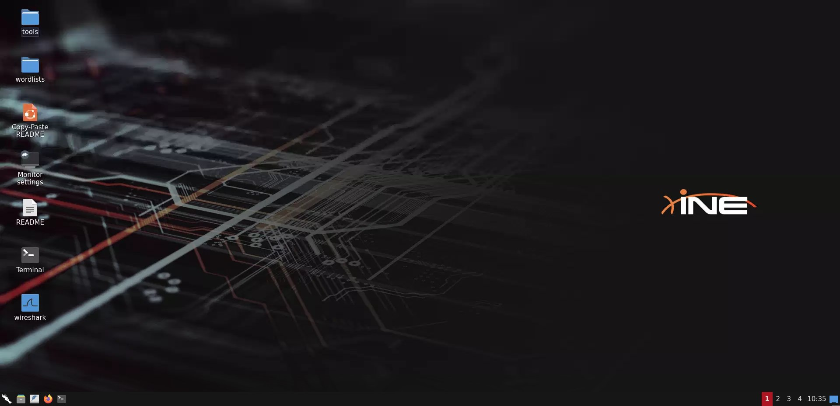

Task 1. Hunt for malicious use of rundll32
After visiting the provided link in the task's description, we find out that rundll32.exe can call pcwutl.dll which has the ability to execute an application. Utilizing that information, we can construct the following query (against the available Sysmon logs):
process.name:rundll32.exe AND (process.args:pcwutl.dll AND process.args:LaunchApplication)
Once the query is executed, we get the following match:
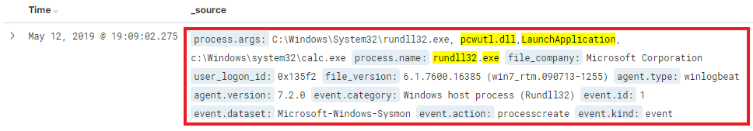

Task 2. Hunt for UAC Bypass
Following the provided hint, we focus on technique 7. According to the documentation, the bypass is implemented through an abuse of "cliconfg.exe". Because the abuse requires that cliconfg.exe loads "NTWDBLIB.dll", we'll focus our detection exactly on that, specifically filtering for Sysmon's Event ID 7 -- Image loaded. Therefore, we construct the following query:
event.id:7 AND (process.name:cliconfg.exe AND file.path:NTWDBLIB.dll)
Once executed, we get the following match:
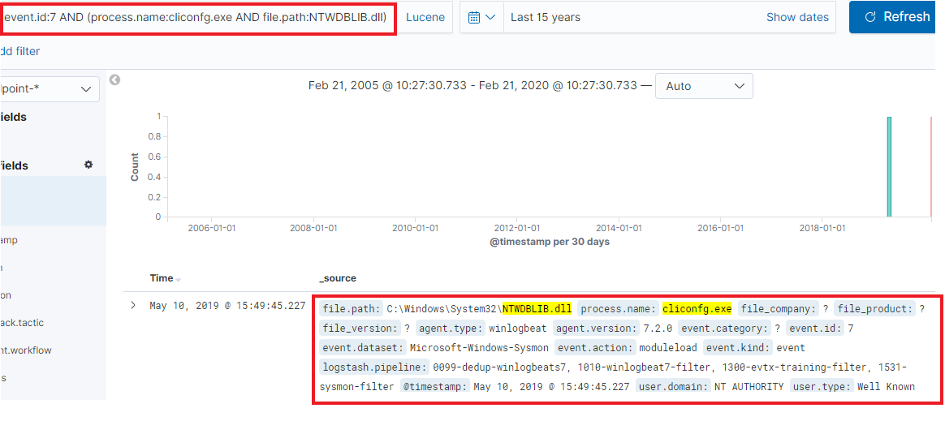

Task 3. Hunt for RDP Settings tampering
Taking into account the hint provided, if any RDP tampering or abuse (eg. RDP tunneling etc) is to occur, RDP should first be enabled. Therefore, our detection will focus on detecting whether RDP has been enabled. One of the common ways to do this, is to monitor if netsh is used to create a firewall rule that allows an RDP connection. Therefore, we focus our detection on Sysmon event ID 1 - Process Creation. Finally, we construct the following detection rule:
event.id:1 AND (process.name:netsh.exe AND (process.args:localport=3389 AND process.args:action=allow))
Once executed, we get the following match:
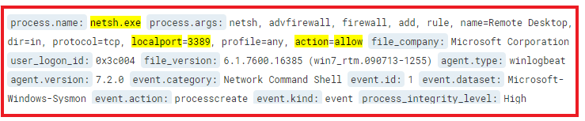
Clearly, enabling RDP on its own is not necessarily malicious, therefore, additional effort is required to conclude that. Nonetheless, tampering has occurred.

Task 4. Hunt for DCSync
One way to obtain a detection rule is by looking at Sigma, specifically the DCSync detection rule here. We therefore construct the following query:
event.id:4662 AND NOT (user.name:*$ OR user.name:AUTHORITY OR user.name:Window) AND (object.properties:1131f6ad-9c07-11d1-f79f-00c04fc2dcd2 OR object.properties:Replicating)
Once executed, we get the following match:
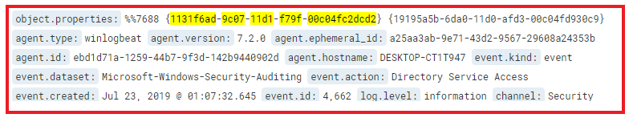

Task 5. Hunt for Remote WMI Usage
If we pay attention to the provided links and hint, we'll identify that remote usage of WMI will create an Event ID 4648 -- logon with explicit credentials, with source process of wmic.exe. That is illustrated on the image below:
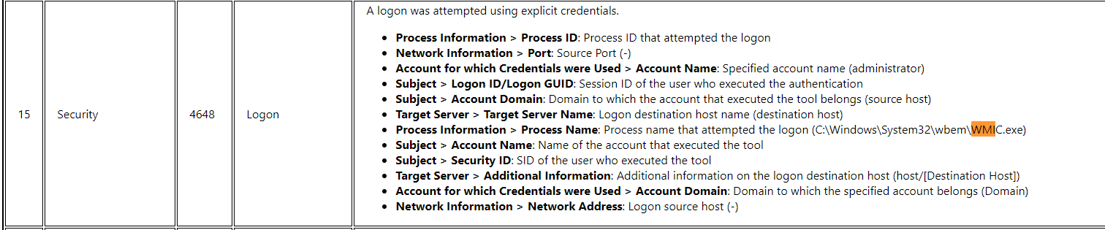
Utilizing that, we can create our detection technique and construct the following query:
event.id:4648 AND process.executable:WMIC.exe
Once executed, we get the following match:
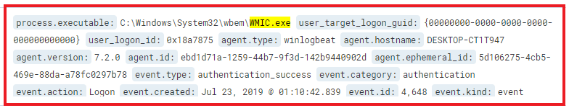
If we expand that entry, we'll get more details on the account(s) associated with the login:
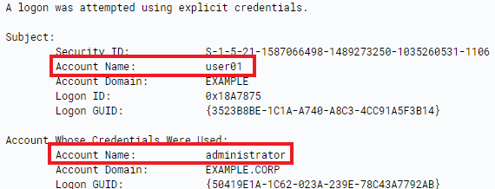

Task 6. Hunt for LOLBAS openurl
Let's take into account everything the hint of this task mentioned as well as Sysmon Event ID 1 - Process Creation, to construct a detection query as follows:
process.executable:rundll32.exe AND process.args:(url.dll OR ieframe.dll OR shdocvw.dll)
Once executed, we get 5 matches. A single match with ieframe.dll, which opens a URL file from a temporary directory:
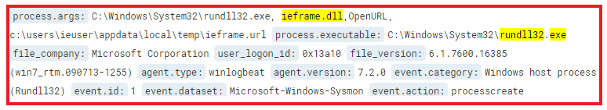
The other 4 matches are related to url.dll. As we can see below, one of them executes an .hta file:
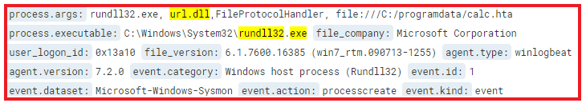
The fact that .hta file is being executed means that mshta, as the default handler, will be called. Therefore, if we utilize the following query, we can confirm that calc.hta gets executed by mshta:
process.executable:mshta.exe AND process.args:calc.hta
Once executed, we receive the following match:
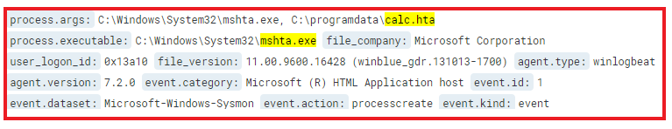

Task 7. Hunt for persistence through scheduled Tasks
By researching the provided URL, we identify that both "at.exe" and "schtasks.exe" can be used to schedule a task on a Windows host. While "at.exe" is rarely used, we are interested in any occurrence of its execution but for "schtasks.exe", we'll only look into those that are creating new tasks. The detection is based on Sysmon Event ID 1 - Process Creation. Finally, we construct the following query:
event.id:1 AND ((process.executable:schtasks.exe AND process.args:create) OR process.executable:at.exe)
Once the query is executed, we'll get the following match:
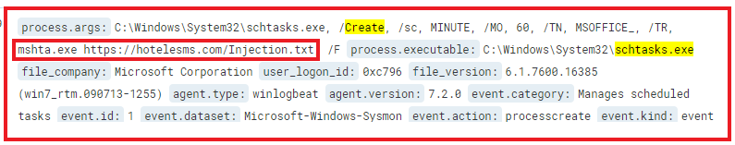
On the output above, we can see that an action that executes "mshta.exe" against a remote URL address is added. To verify that the command executed successfully, we can perform another search for Sysmon Event ID 11 - File Create and search whether a task with the filename provided is now available under C:\Windows\Tasks where all tasks are stored:
event.id:11 AND file.path:MSOFFICE_
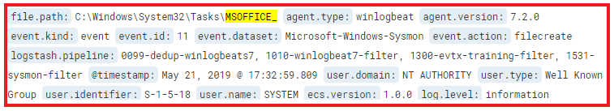

Task 8. Hunt for UAC Bypass #2
After reviewing the linked blog post and studying the method described, we identify that a detection technique would be to monitor the registry key at:
"HKCU:\Software\Classes\exefile\shell\runas\command\isolatedCommand"
However, in our experience, the location of the key may change slightly, therefore, the exact location we'll be looking for is any registry key that contains "shell\runas\command\isolatedCommand". To monitor registry key events, we will utilize Sysmon Event ID 13 -- Registry event. Finally, we construct the following query:
event.id:13 AND registry_key_path:"shell\\runas\\command\\isolatedCommand"
Once the query is executed, we get the following match:
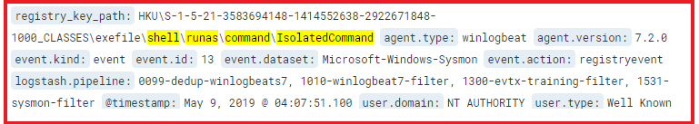
If we expand the entry, we'll see the value which is added to the key:
Upon successful elevation, notepad.exe will start in high integrity.

